**Name: Anees Ahmed.**

**Reg No: Sp20-BSE-053.**

***Use Case: make_Payment***

***Communication Diagram:***

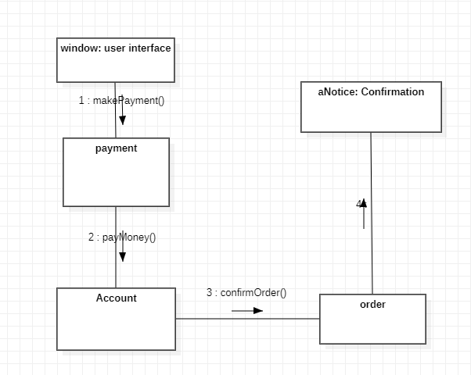

***Use case Description:***

After selecting product buyer will select available payment options like easypaisa, jazzcash, bank account and if they don’t have account in any of them he will pay on delivery. Also buyer must have cash in account. He can pay multiple orders payment at one time by just adding orders and payment will also be added and buyer will pay against all orders. If buyer pay successfully he will receive message.

***Use case diagram:***

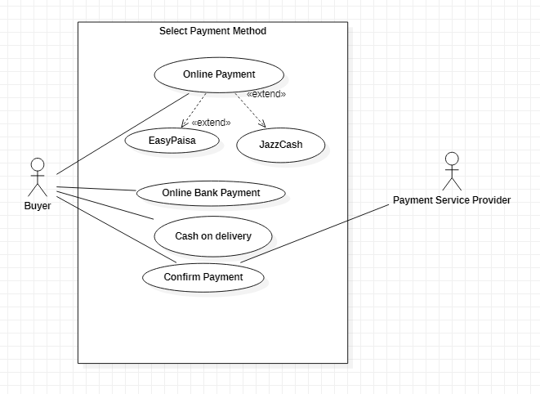

***Fully Dressed Use case:***

|  |  |
| --- | --- |
| **Name** | Select Payment Method |
| **Scope** | We will add payments methods if some new method come into market |
| **Level** | Our goal is to provide all available online payment methods and sub functions are easypaisa or jazzcash |
| **Primary Actor** | Buyer. |
| **Stakeholder and Interests** | 1. Seller: Who wants to sell the product 2. Buyer: Who wants to but the product 3. TCS: who get delivery charges |
| **Preconditions** | Every user must have an account in application. User must fulfill payment methods and also have online account. |
| **Postconditions** | User receive message that payment is selected successfully |
| **Main success scenario** | User provide correct account information in online payment method |
| **Extensions** | Accounts details should be valid |
| **Special requirements** | * Provide security (online payment method should be authentic, user can trust on it). |
| **Frequency of Occurrence** | Every time user place order, Select payment against orders. |

***SSD Diagram:***

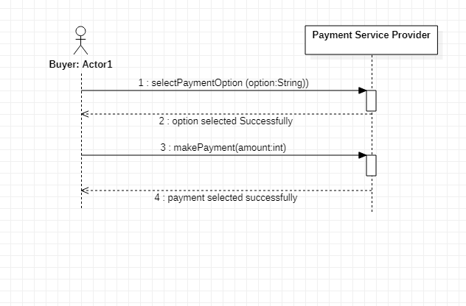

***Operational Contract:***

|  |  |
| --- | --- |
| **Operation** | selectPaymentOption(option:String) |
| **Cross Reference** | Select Payment Method |
| **Pre-Condition** | User should have account in available online payment methods |
| **Post-Condition** | Buyer should go to login page to enter his account details(email,password etc) to pay the amount in entered option. |

|  |  |
| --- | --- |
| **Operation** | makePayment(amount:int) |
| **Cross Reference** | Select Payment Method |
| **Pre-Condition** | Buyer must have balance in account. |
| **Post-Condition** | After confirming payment user must receive message that he does payment successfully. |